Butterfly Tracking System (BTS)

Use Case Specification Document

UC-2
Session Management
Version No. 1.1

Project Document Revision History
VersionNumber | Date | Revision Author | Description of Revision
1.0 | 11/16/2015 | Issam Jassim | Initial Creation
1.1 | 11/22/2016 | Issam Jassim | Made multiple changes/corrections

Table of Contents
1. Introduction 4
2. Use Case Information 4
2.1 Actors 4
2.2 Use Case Interaction 4
3. Trigger 4
4. Pre-condition(s) 5
5. Post-condition(s) 5
6. Use Case Swimlane (Activity) Diagram 5
6.1 User Registration: 5
6.2 User Login: 6
6.3 User Logout: 7
7. Main/Basic Flow(s) of Events (Happy Path) 8
7.1 User Registration: 8
7.2 User Login: 9
7.3 User Logout: 9
8. Alternate/Exception Flow of Events 10
8.1 User Registration, Invalid Data: 10
8.2 User Registration, Email Already in Use: 10
8.3 User Login, Invalid Data: 10
8.4 User Login, No Match Found: 11
9. Assumptions/Business Rules including Non-Functional Requirements 11
10. Use Case Specification Review and Signoff 11

Introduction
The purpose of Session Management is to control user access to the System as well as keep track of all changes made by different users. This use case will cover three distinct but closely related functionalities:
- User Registration: Enables visitors/guests to create an account to gain more privileges (become Registered Users).
- User Login: Enables registered users to login using their credentials (username/email and password), so they can report/update their own butterfly tagging/sightings and manage their account.
- User Logout: Enables users that area already logged in to log out to keep their accounts secure.
The users of the system will be divided into three categories. The categories from lowest level of privileges to highest are: Guests, Registered Users, and Administrators. A brief description of each user category is given below:
Guest: Any user that visits the website. This type of user will not require an account and will have limited access to the system. Guests will be able to view or download butterfly tracking information, but will not be able to make any changes to the database.
Registered User: A user that has an active account in the system is considered to be a registered user. This type of user can report and update own butterfly taggings and sightings, as well as make changes to his or her account information.
Administrator: This type of user has the highest level of access to the system. Therefore, in addition to all privileges enjoyed by registered users, this user will be able to update all taggings and sightings, as well as manage all user accounts, which includes granting them administrator status.

Use Case Information

Actors
Actor Name | Role | Description
Guest | Main | Any user who visit the BTS website
Registered User | Main | Any user who has an account in BTS
Administrator | Main | Registered users with Administrator status

Use Case Interaction
This use case has no predecessors, but it has a few successor.
The following Use Cases are dependent upon Session Management:
- UC-3 Create Butterfly Tagging/Sighting
- UC-4 Update Butterfly Tagging/Sighting
- UC-5 Management
See the appropriate Use Case Specification Document for more information about the use cases above.

Trigger
The triggers for each functionality are described in the following table:

Functionality | Trigger
User Registration | Register button clicked by the user
User Login | Login button pressed by the user
User Logout | Logout button pressed by the user

Pre-condition(s)
While this use case is not dependent upon any other use case, some of the functionalities within this use case are dependent upon another. To access the following functionalities, the following conditions must be met:
User Registration: User must not already be logged in, or must be logged out.
User Login: User must not already be logged in.
User Logout: User must already be logged in.

Post-condition(s)
The Session Management use case will cover three functionalities, and each of those functionalities will have a different post condition. See section 7 for more details.
Below is a breakdown of each functionality covered by this document as well as its post-condition:
- User Registration: User account will be created and added to the system.
- User Login: User will be logged into the system as a Registered User.
- User Logout. User will be logged out of the system and the user’s status will be set to guest.

Use Case Swimlane (Activity) Diagram

User Registration:
In the following diagram, user refers to Guests and any Registered Users or Administrators that are not currently logged in, as the system will allow them to register for new accounts.
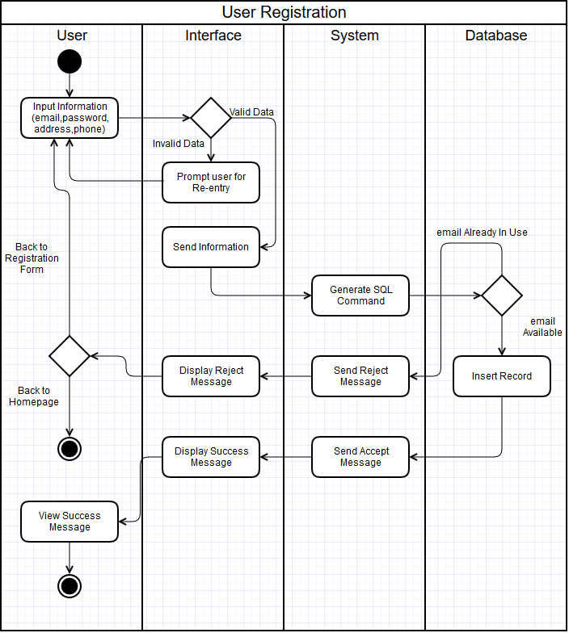
Diagram 6.1 Version 1.0 11/16/2015

User Login:
In this diagram, user refers to both Registered Users and Administrators.
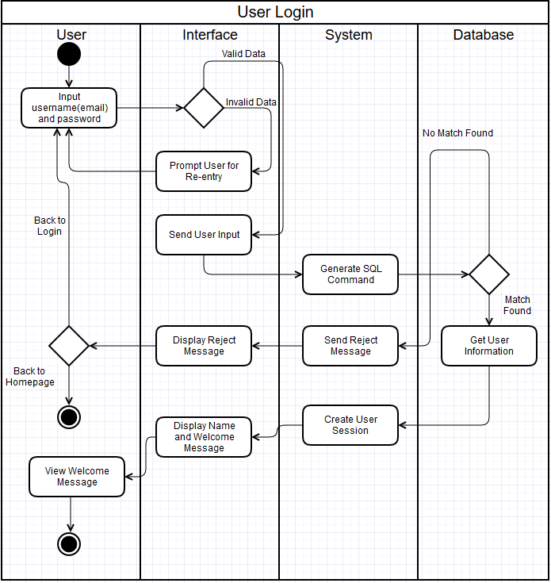
Diagram 6.2 Version 1.0 11/16/2015

User Logout:
In this diagram, user refers to both Registered Users and Administrators.

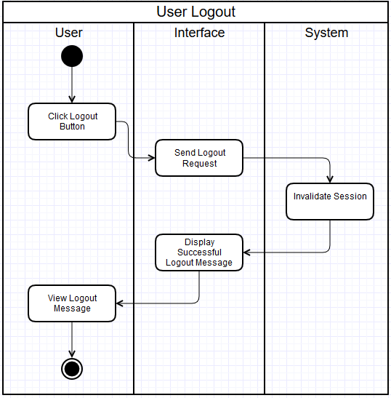
Diagram 6.3 Version 1.0 11/16/2015

Main/Basic Flow(s) of Events (Happy Path)

User Registration:
In the following flow, user refers to Guests and any Registered Users or Administrators that are not currently logged in, as the system will allow them to register for new accounts.
See Diagram 6.1 for a visual representation.
      - User enter information (email, password, address, phone number) and click submit button.
      - The interface will check for valid data.
      - Interface will forward input information to system.
      - System will generate SQL commands and send to database.
      - Database will ensure email address is not already in use.
      - Database will insert the user information to users table and notify system.
      - System will send accept message to interface/
      - Interface will display success message.
      - User will view success message.

User Login:
In this diagram, user refers to both Registered Users and Administrators.
See Diagram 6.2 for a visual representation.
      - User will input username (email) and password and click submit button.
      - Interface will check for valid data.
      - The interface will submit data to system.
      - The system will generate SQL command and sent to database.
      - The database will find matching user information and forward to system.
      - The system will create user session and send to interface.
      - The interface will display user name and welcome message.
      - The user will view welcome message.

User Logout:
In this diagram, user refers to both Registered Users and Administrators.
See Diagram 6.3 for a visual representation.
      - The user will click the logout button.
      - The interface will forward logout request to system.
      - The system will invalidate session and notify interface.
      - The interface will display successful logout message.
      - The user will view logout message.

Alternate/Exception Flow of Events

User Registration, Invalid Data:
See Diagram 6.1 for a visual representation.
      - User enter information (email, password, address, phone number) and click submit button.
      - The interface will check for valid data.
      - The interface will display appropriate invalid data message and prompt for reentry.
Invalid data message can be one of the following:
- Invalid Email: Either empty field or not a valid email address.
- Invalid Password: Password must be at least 8 characters long.
- Invalid Address: Empty address field.
- Invalid Phone number: Phone number must be 10 digits.
      - The user will start over by reentering data.

User Registration, Email Already in Use:
See Diagram 6.1 for a visual representation.
      - User enter information (email, password, address, phone number) and click submit button.
      - The interface will check for valid data.
      - Interface will forward input information to system.
      - System will generate SQL commands and send to database.
      - Database finds the same email in use by a different user and send reject message to system.
      - System will send “email already in use” reject message to interface.
      - Interface will display “email already in use” message to user”.
      - User will view the “email already in use” message.
      - User will choose to either start over and try with a different email address or go back to home page.

User Login, Invalid Data:
See Diagram 6.2 for a visual representation.
      - User enter username (email) and password and click submit.
      - The interface will check for valid data.
      - The interface will display appropriate invalid data message and prompt for reentry.
Invalid data message can be one of the following:
- Invalid Email: Either empty field or not a valid email address.
- Invalid Password: Password must be at least 8 characters long.
      - The user will start over by reentering data.

User Login, No Match Found:
See Diagram 6.2 for a visual representation.
      - User will input username (email) and password and click submit button.
      - Interface will check for valid data.
      - The interface will submit data to system.
      - The system will generate SQL command and sent to database.
      - Database will not find a user matching input data (must match both email and password).
      - The database will send no match found message to system.
      - System will send reject message to interface.
      - The interface will display reject message.
      - The user will either go back to login page to retry (start over), or go to homepage.

Assumptions/Business Rules including Non-Functional Requirements
The browsers that are used to access to the system are modern and capable of properly displaying the forms and messages generated by the system.

Use Case Specification Review and Signoff
Review and Signoff of the Use Case Specification
Name | Project Team Role | Signature | Date
Issam Jassim | Team Leader | Ikj | 11/24/2015
Yue Dai | Front-end Developer | Yd | 11/24/2015
Xiuyan Xin | Front-end Developer | xx | 11/24/2015
Nesrin Mohammed | Database Manager | nm | 11/24/2015

